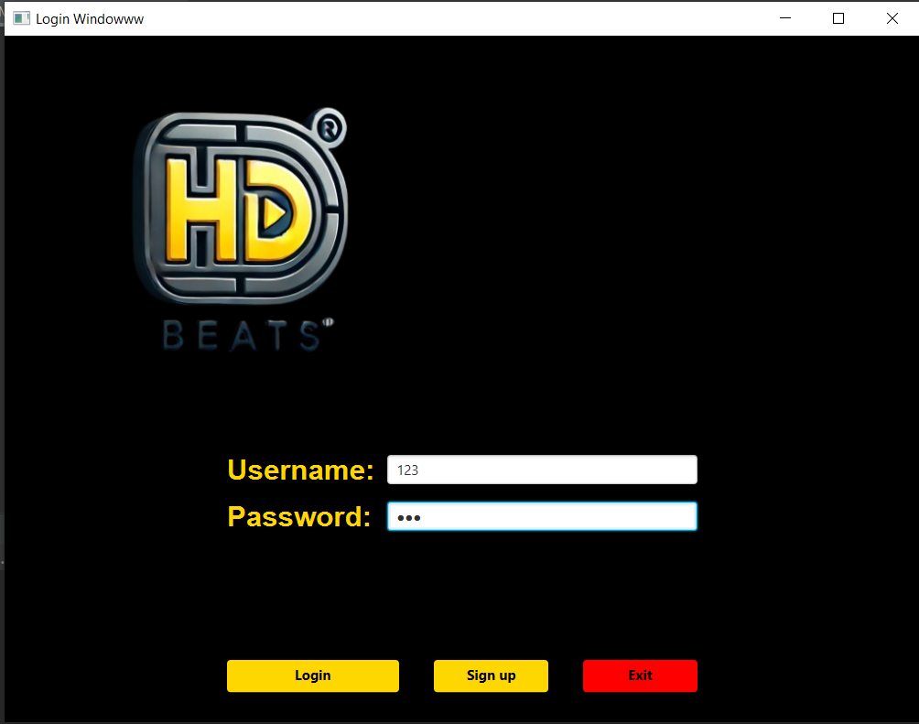First there is a login screen, we can sign up as well by adding new user name and password, and then login using those credentials.

We user border pane as main layout, and then inserted the gridpane in the centre for user and password fields and buttons:  
  
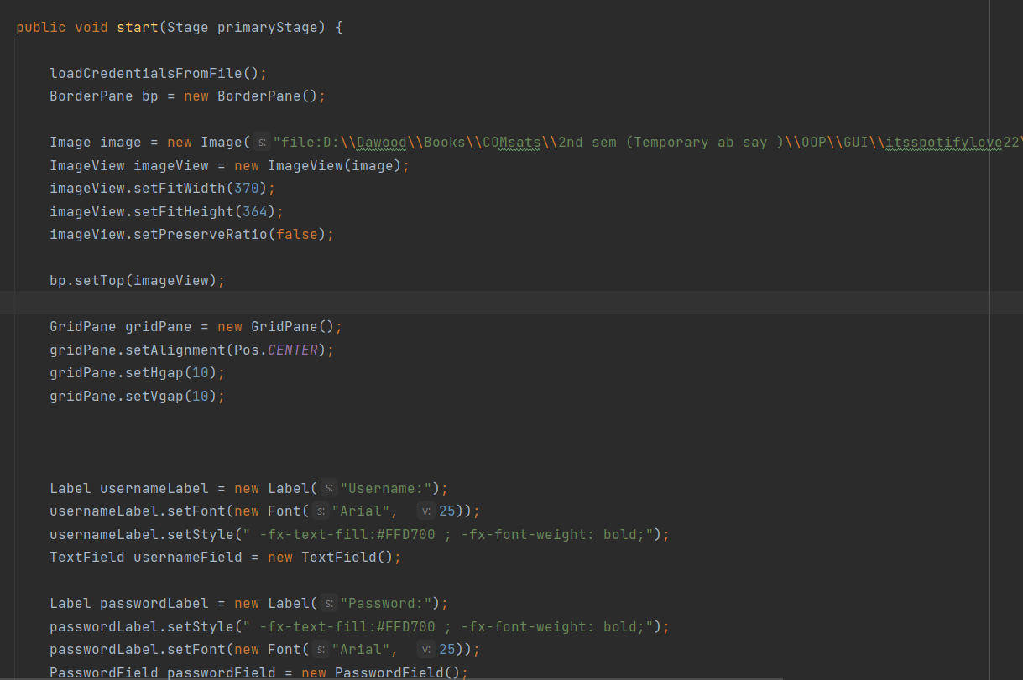

Below is our main window, which has a search bar and search button in V box, and then there is a which is added in the top of the borderpane,   
then we have a Vbox in the left which has the table view for our downloaded songs, and then in the centre we have table view for the searched songs that our API has fetched from YouTube’s database,  
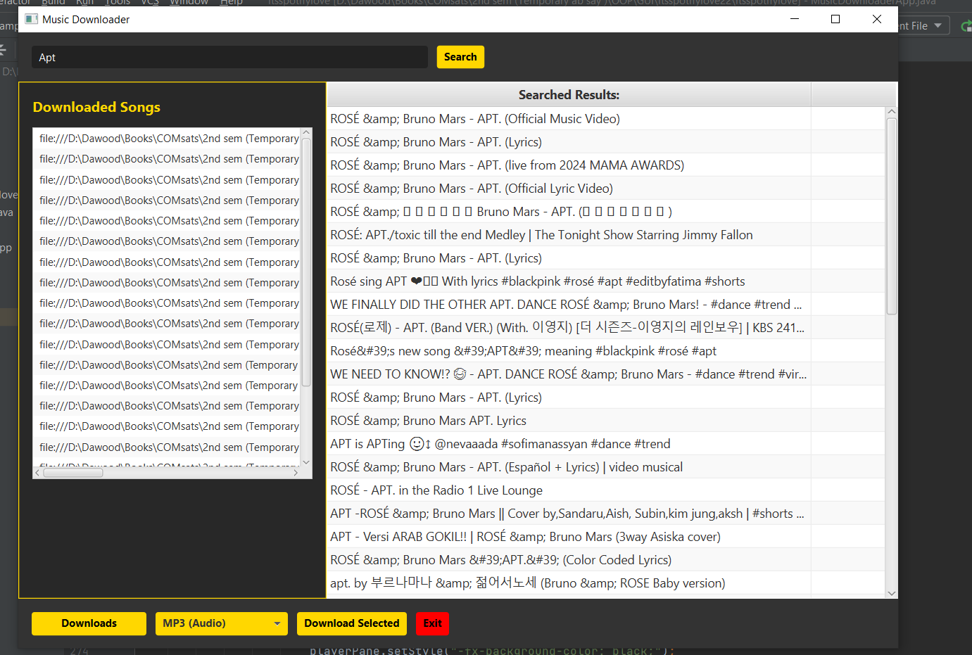

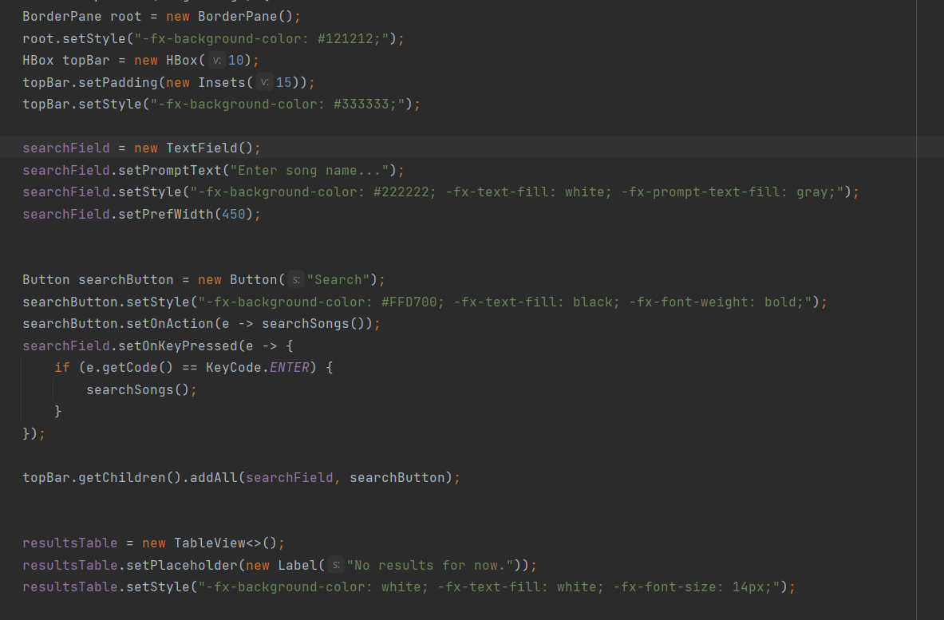

The download logic:  
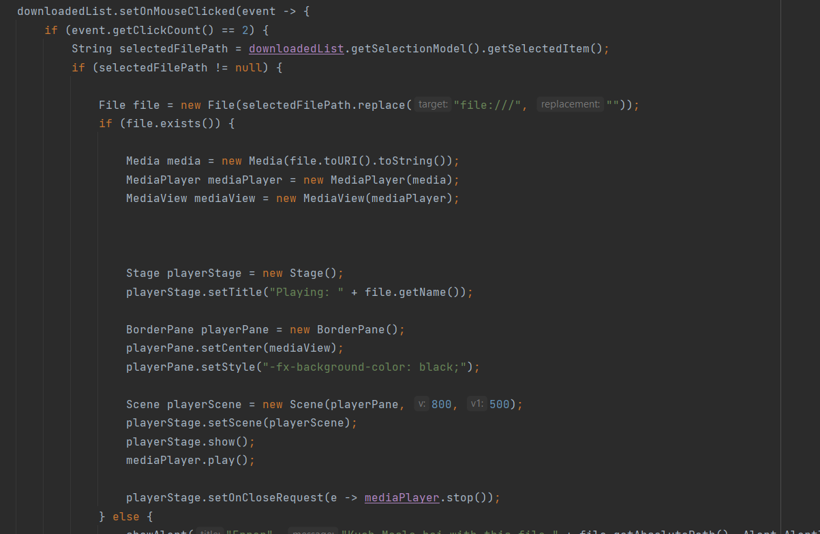

Search function  
